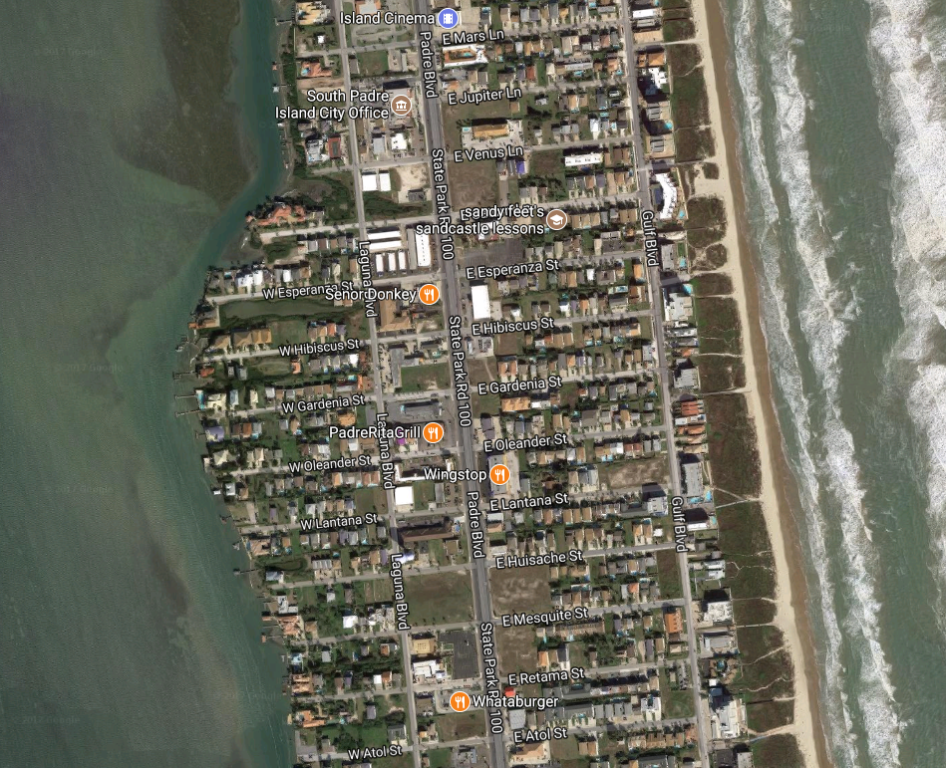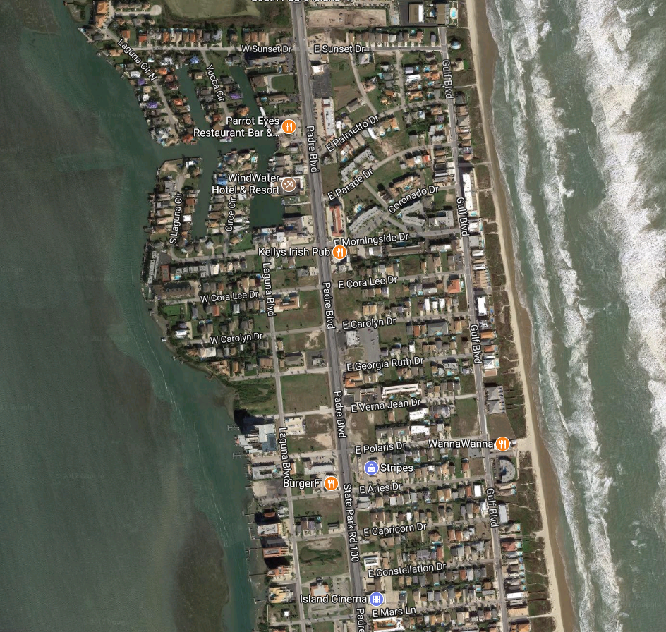

Water Tower Park

Beach Access #18

SPI Triathlon

Sprint Run Course

= Start

= Finish

= Water Station